5. Modulation of autoISF aggressiveness. V 4.6
Please note that with autoISF you are in an early-dev. environment, where the user interface is not optimized for safety of users who stray away from intended ways to use. Good safety features exist, but these are only as good as the development-oriented user understands and implements them. This is not a medical product. Refer to disclaimer in section 0/readme.md

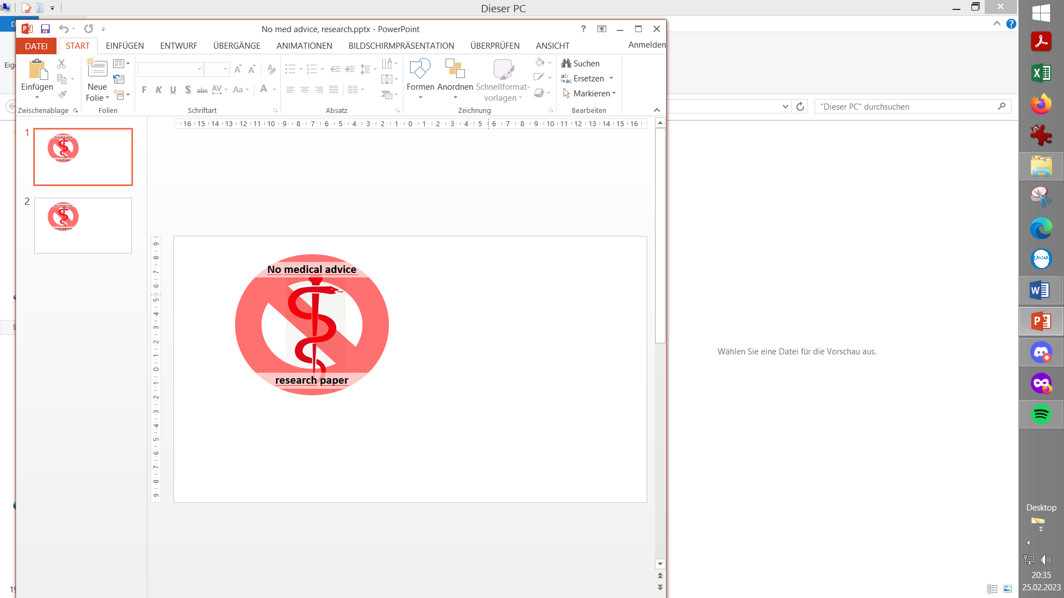

5.1 Automatic modulation of loop aggressiveness
Available (related) case studies:

Case study 5.2: Sweet snack.
Case study 5.3: Compression low

5.1.1 “autoISF off” outside of meal times
5.1.2 SMB off @ odd profile target
5.1.3 SMB off @ odd temp. target
5.1.4 diff. of FCL aggressiveness via Automations
5.1.5 diff. of FCL aggressiveness via Activity Monitor
5.1.6 Pro/con completely hands-off FCL
5.2 Manual modulation of FCL aggressiveness (DIY cockpit)
5.2.1 Status recognition
5.2.2 Manual interventions from DIY cockpit
5.2.2.1 Temp. %profile or TT settings
5.2.2.2 Temp. settings in /preferences
5.2.2.3 Grey DIY cockpit buttons for FCL responses
5.2.2.4 Diff. of FCL aggressiveness using “Automation State”
5.2.3 Temporary exit from FCL
5.3 Recognizing loop state from the AAPS home screen
5.3.1 Modulated loop aggressiveness (3 top buttons)
5.3.2 Color scheme of the top 3 buttons
5.3.3 Active Automations
5.3.4 FCL related indicator fields
5.3.5 Overall AAPS home screen
5.3.6 Client screen
5.3.7 Extra Graphs for autoISF
5.3.8 Info given every 5 minutes in the AUTO ISF tab
5.3.9 Info about last 15 autoISF decisions
5.3.10 AUTO ISF tab info when operating 1-minute Libre
Summary: Your personal FCL cockpit

Once the initial tuning according to section 4. is done, you are ready to use autoISF for your fully automated meal management.

Challenges beyond managing main meals

There are up to four other major challenges you might have to manage:

- Secure the technical pre-requisites for your FCL remain a given (see section 1):
  - Prevent, recognize and manage (partial) occlusions (=>frequent cannula changes)
  - Secure “meaningfulness” of 100% all your CGM values
  - Secure 24/7 BT connectivity of all your components
- Deal with times when insulin given, after meal detection, must be restricted, e.g.:
  - a snack should not be “treated” as a meal
  - meal before exercise should not be treated “all the way” towards high iob.

- Deal with times when the loop should be set "less aggressive" as a precaution, e.g.
  - during nights
  - in an exercise context

- Deal with times when the loop should be set "more aggressive" e.g.
  - at sickness
  - at tempting hotel breakfast buffet, or other “diet sin” + in-activity

How big the remaining challenge really is, depends very much on your targeted %TIR and:

- on your individual lifestyle: => is your loop (automatically, section 4.1, or via a needed intervention, section 4.2) prepared to respond with required different aggressiveness?
- on quality of your tuning: => will your loop frequently “drift outside of the desired corridor”? Will it automatically recognize this, and pull back into it? Can you recognize it, and pull back earlier?

Hands-off FCL – an elusive goal?

To run the FCL “hands-off” around the clock, you now must analyze your data also in the times outside the meal blocks, and seek solutions to problems (if any).

With a technically well-functioning system, moderate meals, moderate exercise, moderate %TIR expectations and a bit of mindfulness it should be possible to go into Full Closed Loop 24/7, after working through, and observing, sections 1-4. See case study 4.3.

- In section 5.1 we explore avenues towards fully automated management of some other “disturbances” that, in daily life, also will not require any user intervention.
Often it will be your choice whether you want to bother with researching in your data for, and defining, dedicated (“personalized”) Automations (see also section 5.1.6.).
Or whether you accept instances where you do manual steps:

- In section 5.2 (and later, related to exercise, in section 6.) we will look at solutions that involve an easy user interaction like a data entry, or a button push.

Avenues for temporary (automatic or manual) modulation of the FCL aggressiveness

- temporary shut-off SMBs (via odd -numbered target)
- temporary change ISF-weights
- temporary change iobTH_percent
- temporary change the set %profile
- temporary set different bg target (especially in connection with exercise mode)t

All of these are also easy accessible via Automations in AAPS
This means: If, in your data, you find sets of conditions where any of the actions 1.-5. could help, you can make this aspect integrated part of your hands-off FCL!

5.1 Fully automatic modulation of FCL aggressiveness

The following subchapters describe set-ups you may want to use for allowing completely hands-off FCL in as many daily situations as possible (and potentially all the time, as in case study 4.3)

Note that in Automations you can go beyond above mentioned 5 avenues, and come up with a nearly surgical definition as to from which iob on, and many other criteria, some temporary modulation of aggressiveness shall happen.

5.1.1 All autoISF ISF adaptations switched off outside of meal-time windows

If, aside from having to bolus for meals, your hybrid closed loop was running pretty well without other interventions from your side, you could continue to run in that mode, and just focus your new autoISF FCL on management of meals.

In your initial transitioning phase, this approach makes a lot of sense, and even by focusing autoISF on just a sub-set of meals, like only dinners.
Also in the long run this avenue is taken by many FCL users for the night times, “hanging on” to their well performing hybrid closed loop with standard oref(1) SMB+UAM

To install this mode, you define Automations

- that set meal time windows in which “Enable ISF adaptation by glucose behavior” (autoISF) is turned on in AAPS preferences/OpenAPS SMB
- or: that turn all autoISF’s ISF modulations (or just bgAccel_lSF ) off in time windows in which surely no meal occurs.
For instance, you can go for all nights back into your Hybrid Closed Loop, as you had before.

Your temp. “autoISF shut-down” (exiting autoISF FCL = shutting off “Enable ISF adaptation by glucose behavior“ in AAPS Preferences / SMB) is meant to prevent problems from the loop over-reacting to bumps in the glucose curve in times of day (night), when standard oref(1) performance is sufficient.

A very good alternative to defining “meal-time windows”, or to resorting to night-time Hybrid Closed Loop, is letting the autoISF FCL run 24/7, and “taming” the FCL via a night time SMB shut-off (see next section 5.1.2).

Off topic: Other “early dev” AAPS variants (see section 13.3), do require working with meal-time windows. The window is either set by time of day in the settings, or it always must be „set“ by the user. Trigger to set a meal time window could be a pre-bolus given by the user, a carb entry made, an EatingSoonTT set, or a meal-announcement-button pushed (none of these things are required in autoISF FCL).
Outside of these time windows, these loops then run with less aggressive SMBs, just like oref(1) SMB+UAM in AAPS Master, with or without (modified versions of) dynamicISF. So, outside of the meal time windows, you would be in “your normal” hybrid closed loop.
The term Meal Announcement (MA) is often used to label this closed looping mode.
It is not really FCL, but an advance over traditional HCL.

5.1.2 Odd-numbered profile targets, to block SMBs

An alternative route of preventing the FCL loop from over-reacting to bumps in the glucose curve would be to make use of the option to temporarily shut down SMBs

Ensure the even/odd logic in the settings is toggled on in Preferences> openAPS SMB> autoISF settings> smb delivery settings>: "Enable alternative activation of SMB depending on bg target”: ON.

In time blocks with an odd-numbered profile target you can prevent any SMBs being given by your loop. The (unchanged) aggressive settings then can only translate within the limits set by %TBR possible.

This will very much slow down any more insulin being given, and is an excellent solution for night times, especially if you occasionally experience compression lows.

Alternatively, you could use the new included options for Automation Conditions and
- allow/block SMBs via Automation commands, or:
- temporarily tune your bgAccel_ISF_weight much lower (see section 5.1.4).

The same situation can be achieved if you generally operate with a mild bgAccel_ISF, and make your autoISF only really aggressive for meal-time slots (if you have similar enough times every day, or also can “employ” geo-fencing in your Automation (or middleware, in iAPS) conditions).
In these cases you would not need to have night profiles that disable SMBs: - Which is the better way would depend on a lot of personal factors relating to how high-carb the diet is, regularity of meals, snacking habit, CGM quality and incidence of compression lows, and probably more. - I would try both routes, or, as this is fairly complex to tune, just one, and stick with what is working good enough.
Yet another alternative was already presented (section 5.1.1) = to go into hybrid closed loop for the night.
That is possible, with SMBs available (without them getting boosted via autoISF), and, for a long time, was the author’s favored solution for the nights.
This solution is evidently similar to the prior discussed one, of having a mildly tuned autoISF 24/7, boosted to high aggressiveness only in meal-time slots.

Adjunct Automations to allow a few SMBs, in nights with odd profile target SMB shut-out

My favorite builds on the method of this section (5.1.2, odd profile target provides SMB shut-out at night), but then allowing some, automatically triggered SMBs, when needed:

In case you occasionally do have nights that would benefit from a couple of SMBs (to treat temp. highs from a late fatty pizza, raclette and such): Define suitable Automations like the two „night“ ones in this example:
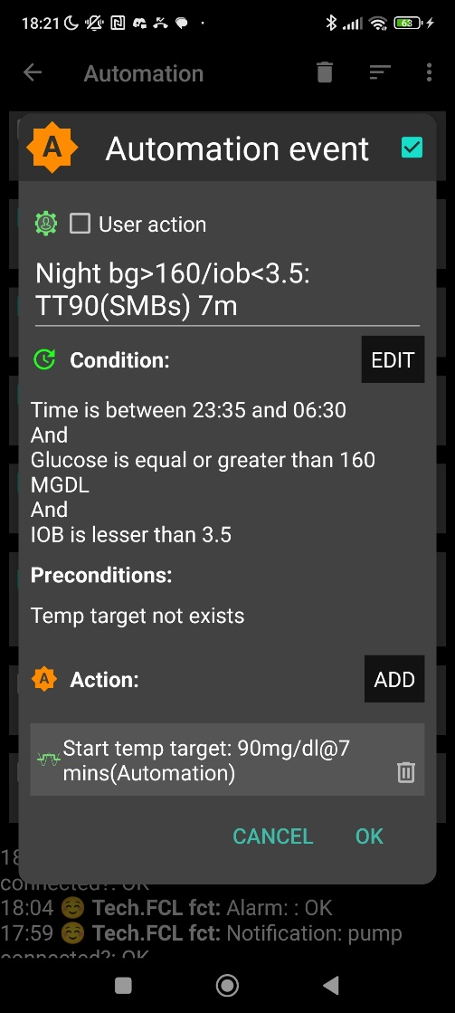
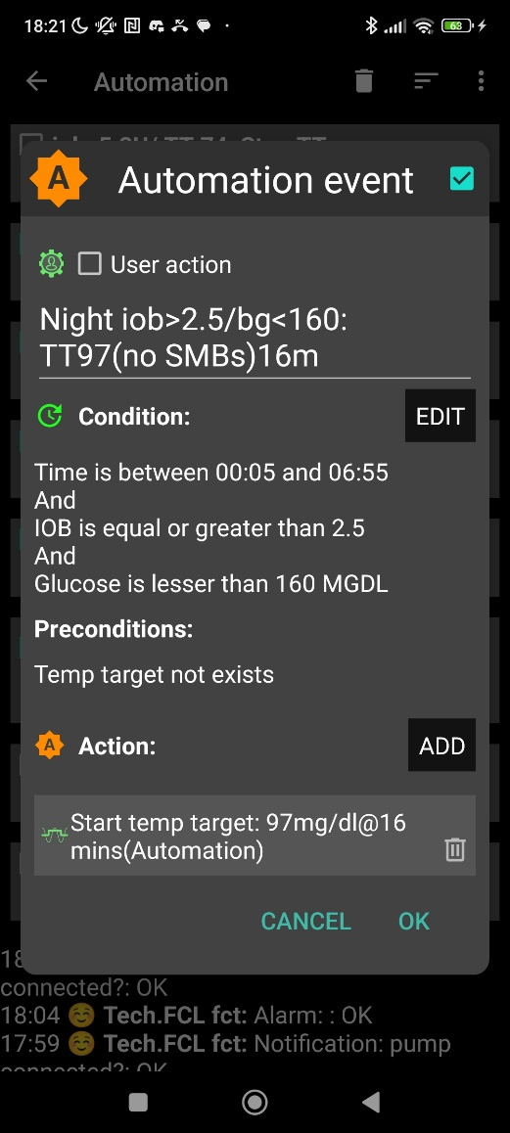

Caution: Never underestimate the „trickiness“ of getting your Automations „right“.

With your thought-out Automations in place, night data need to be analyzed to see
- whether the bg and iob limits, as defined in the given example, work sensibly four your data pattern
- whether the TT duration is chosen appropriately
- how swapping the sequence in which the automations appear in the Automation list would lead to different SMB impacts.

5.1.3 Odd-numbered temp. targets (TT) set via Automation, to block SMBs

A widely used Action that strongly modifies how fast your FCL can add more iob is setting an odd-numbered temp. glucose target which makes the loop operate without giving any SMBs (%TBR modulation only).
Ensure the even/odd logic in the settings is toggled on in Preferences> openAPS SMB> autoISF settings> smb delivery settings>: "Enable alternative activation of SMB depending on bg target”: ON.

Then, from patterns you find in your data, at times where you want your loop act differently, you need to carve out Conditions that describe the respective situations (and either for how long it typically lasts, or at which other Conditions you want your loop get back to default FCL operation).

An odd TT is often set for an anti-hypo snack or sports snack. In both instances, you do not want SMBs to quickly counter-act.

Note that in case of sweet “fun” snacks, this is entirely different -> section, 5.2.1 or for regular snacks (e.g.at school break) see next section 5.1.4

5.1.4 Automatic differentiation of FCL aggressiveness using Automations (or middleware)

Personalized Automations tailor the loop exactly to your data so fully automated handling of situations with different aggressiveness of the loop can be made.

Automations are an integrated and very easy-to-use feature in AAPS.
(The i-Phone platforms Trio or iAPS lack this feature. However, so-called middleware has been developed as add-in to your code, see: https://github.com/macconnellk/RoboSurfer/tree/main )
.
From, autoISF 3.0 onwards, also the following parameters are provided as Condition and/or as Action for defining YOUR Automations:
- Enable ISF adaptations by glucose behavior => Allows temp. ON/OFF for the key ISF modulation parts of autoISF (and, as a result, will usually decrease loop aggressiveness)
- Trigger/set iobTH percent => Keeps default aggressiveness, but only until a iob threshold (that your Automation modifies) is surpassed (which is when any further SMBs will be blocked blocked)
- Trigger/set bgAccel_ISF_weight => Modifies the aggressiveness of just the acceleration component
To set up suitable Automations, you first must analyze patterns you find in your data, at times (or geo-location, or bg and iob patterns that point to a problem …) where you want your loop act differently, to carve out Conditions that describe the respective situations (and either for how long it typically lasts, or at which other Conditions you want your loop get back to default FCL operation).

A variant of this mode is to define several windows in which autoISF aggressiveness (bgAccel_ISF_weight) and/or iobTH are automatically set differently
- for different meal time slots of your day –
(Breakfast at home, school lunches, school intermission snacks, dinners at home could for example all deserve special settings regarding ISF_weights and iobTH).
Note: Circadian differences in insulin sensitivity between meal times are included via your ISF profile and should not be a reason for different _weights needed between meals!
- or even for a geo-location etc –
(School lunches, or mother-in-law visits, would be examples).
An example for this was given in section 3 already:
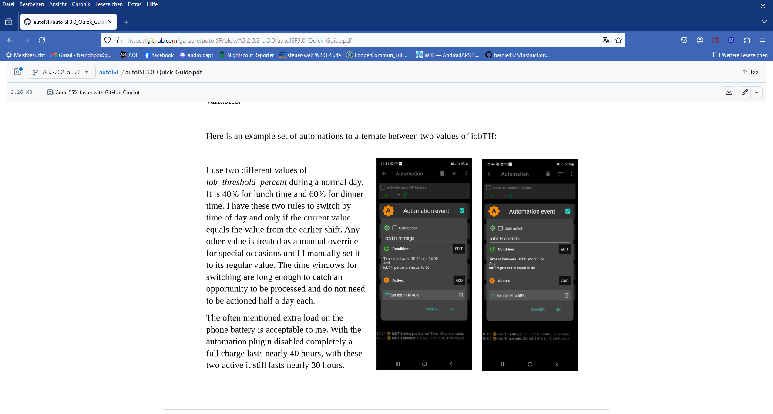
dinner
lunch
Unless your meals differ vastly in size and in fast carb content all this may not be needed.
- Note: Only the main two parameters (bgAccel_ISF_weight for “initial aggressiveness”, and iobTH_percent for “where SMBs stop”) are available in Automations. So, finding your parameter sets for each of the time slots, will not be trivial. => Spending more effort to set the .._weights so they accommodate just one, broader spectrum (section 4.) should be the first, and standard, approach.
- An intermediate (maybe only temporary) approach could be to use a profile switch (for low carb meal, or eating half, setting %profile to 60% for instance, and only for the brief, less than an hour, initial meal period). See section 5.2.2
Still, personalized Automations might help ease your initial job of setting the various ISF_weights, and of finding a best-suitable iob_theshold_percent that would work “always”.

Note: Setting a different iobTH% or bgAccel_ISF_weight can probably not be done with a duration attached. Then you must define a suitable additional Automation (example see next page) that must be active in tandem, to restore the values you had set in /Preferences for your iobTH% or bgAccel-ISF_weight.
Else, once your Automation set in, it will forever shift these important parameter settings!

If for instance you have several Automations that, in combination with a set elevated TT also set a lower iobTH: Don’t be fooled, the duration only applies to the TT.

You need an extra Automation for all of them.

I picked out the highest of the altered iobTH values that these Automations can set (in my case, 45% or lower), and then I can automatically restore my default desired 60%, via this one - -> Automation (see screenshot - - > )

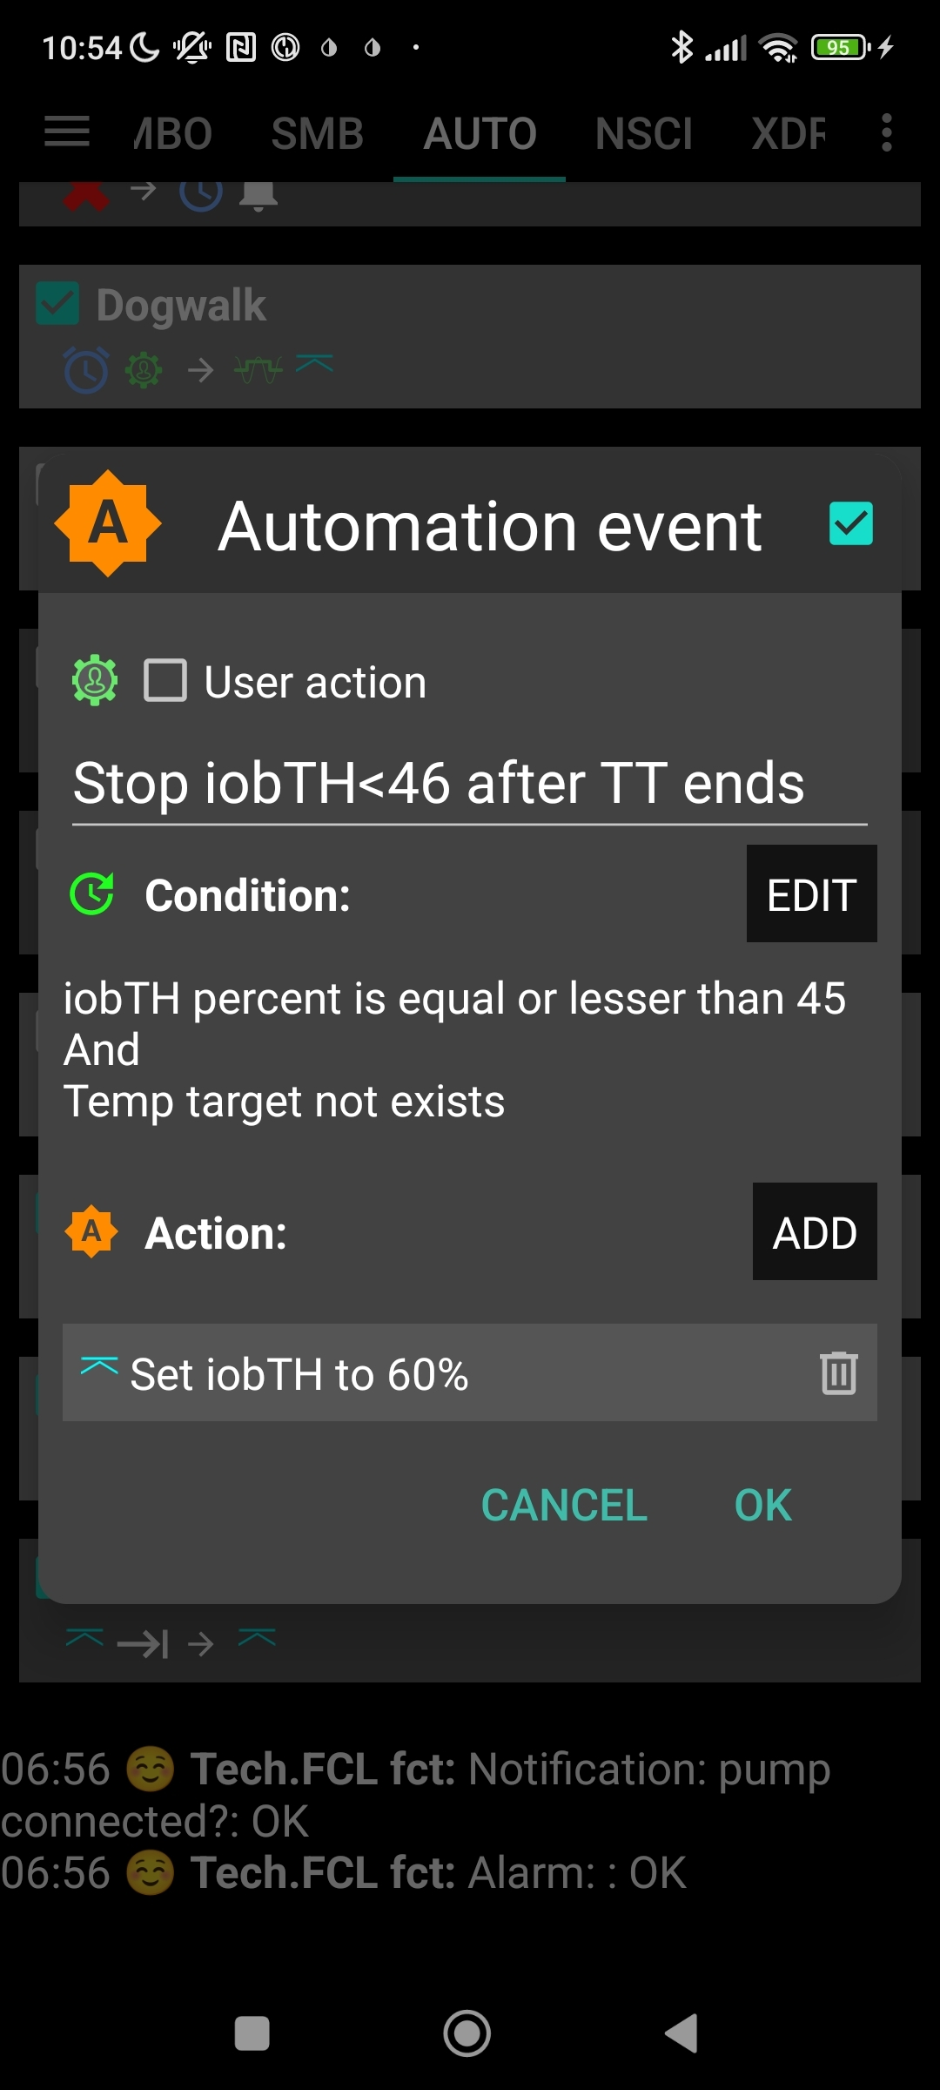

Caution: Resist the temptation to use too many Automations. Notably, do not include Automations that would duplicate (and in effect delay) the job that autoISF tries to do:
Automations: Relative disadvantages to/when using autoISF (Discord 26.8.2025/ chiakii/ ga-zelle):
“..I've made an automation that sets a low TT on high bg deltas, but when it gets triggered, the SMB I get is calculated with the "before TT" weights/values, and only the next tick (next CGM value) will take the low TT into account.
Given that we want to front load the SMBs as much as possible, that’s 5 minutes lost with a high delta, which isn't ideal”
ANSWER: A new bg reading triggers a new loop and checking the automation triggers. Therefore it comes too late.
Your scenario reminds me of cases with too many automations that interfere with the (autoISF) built in control logic! Note that if you observe large delta, then inevitably there was a high acceleration before. In terms of front loading that acceleration could have done its job when you use autoISF. Even a stronger pp_ISF weight would probably help more.

5.1.5 Automatic adjustment of FCL aggressiveness via the Activity Monitor

With the autoISF variant of AAPS you can make use of your smartphone‘s stepcounter and use it to fully automatically adjust insulin sensitivity ratio to activity level in the past minutes to one hour time frame.

This feature comes with yet another little tuning opportunity, in which you study your body’s response to light exercise (like walking) or to not moving at all (like desk, couch), and select appropriate settings (in AAPS Preferences/OpenAPS SMB/Activity modifies sensitivity/ -> set two scaling factors).
This will automatically adjust insulin delivery (basal, ISF, and iobTH; see 1st screen of AAPS AUTO ISF tab (example in section 5.4.5)), to suit activity state of the past minutes (up to 1 hour).

This autoISF feature (new since V.3.0) is much quicker responding than Autosens or dynamicISF to adjust insulin sensitivity to your current „lifestyle state“ (if it is largely (in-)activity related, which often is the case).
For loopers who do not have huge variations in exercise levels (for which they would need the exercise mode) in their everyday lives, the Activity Monitor might fairly much close the gap towards being able to do a 24/7 hands-off FCL.

The Activity monitor is described in more detail on page 9 of the autoISF Quick guide (https://github.com/ga-zelle/autoISF) and in section 6.6

While the Activity Monitor takes automatic care of light deviations from an average activity level, exercise enthusiasts, or heavy workers, should make use of the “heavier tools” (which automatically supersede (shut off) Activity Monitor: Exercise mode, discussed in section 6.)

5.1.6 Pro/con completely hands-off Full Closed Loop

To stay 24/7 in a completely „hands-off“ FCL can be a realistic goal with autoISF, if besides meals also some special challenges, as discussed in this section 5.1, were analyzed and could be addressed. Example see in Case study 5.3.

Clearly it depends very much on your lifestyle, and how interested, willing, and capable you are to recognize, deal with, (and in the future avoid?) situations that get you outside of your desired %TIR on occasion.
So, this is also about what %TIR you are aiming at, and can accept, as it averages out for the week, for instance.
Everybody must weigh for her/himself
- how much upfront effort to put into the setting up process, for getting it all 100% automatic
- or whether to take an easier start, with a couple of situations left to take care of when and as they arise in daily life

Even if a principal capability for a fully automatic “hands-off” running FCL is given, this still
means that
- the user should be knowledgeable about what exactly is going on, and
- have a principal capability to „nudge“, or even to completely take over, in a manual mode.
In the sections that immediately follow, we present the options to nudge or temporarily take over from the AAPS home screen which will be serving as your FCL cockpit:

Section 5.2 describes how you can use available “buttons” from your AAPS home screen to manually “nudge” aggressiveness of your FCL.
5.2 Modulating aggressiveness manually, from your DIY-FCL-Cockpit

Keep in mind:
- The goal should be to interfere with the loop as little as possible
- Avoid technical failures and BlueTooth disconnections lasting many minutes (e.g. by leaving your phone in another room for too long).
The required insulin would still be supplied after BT reconnects. However, the delay can be much more of an issue in FCL than it had been in HCL, where you pre-bolussed.

In the preceding sections 4. and 5.1 we learned that, under certain conditions, your FCL can run fully automatically, without any user interaction.

However: Other disturbances might come up, that influence your temp. insulin sensitivity dramatically, and
- are not noticeable in-time, or foreseeable, by the loop (e.g. your plan to start exercise in an hour or two), but therefore require temporary modified settings in order to remain in-range, and/or
- require a different “starting point” regarding iob and bg, which translates into a different iobTH that should temporarily be set much lower (in case of exercise) or noticeably higher (e.g. with very fast absorbing carbs in a sweet snack “sin”) .

In these scenarios, you must find an easy way to
- manually tweak a setting or two, to temporarily adjust the aggressiveness, or:
- call up, via a button-push, a pre-programmed routine for automatic management with adjusted aggressiveness.
- There may also arise a desire to just exit the FCL mode, and “be your own captain” for mastering a special situation.

    - Status recognition

For peace of mind, to learn, and to stay informed (especially in your initial tuning phase, or when your glucose curve goes in unexpected ways) you must be able to find the key parameters that frame and drive the recent and upcoming loop decisions.

All this is facilitated within seconds right from the AAPS home screen, serving as a FCL cockpit
Before considering any manual interventions into the ongoing FCL, you should be aware of
- the prediction curves (bg, and insulin activity), and
- what the current mode of action is (refer to section 5.3).

On that basis you might be able to “nudge” your loop in order to adjust to the disturbance that you see coming up:

5,2.2 Manual interventions from the (DIY-) FCL cockpit

5.2.2.1 Temporary tuning of FCL aggressiveness via the top button row on AAPS Home screen (temp. %profile; exercise; TT settings)

%profile set

The set % profile multiplies with both, the ISF resulting from autoISF, and also with the default iobTH you have set, so both are nicely modulated in a linear way with the % temporarily chosen

Just taking profile e.g. to 110% for an afternoon might be an easy way to explore whether you might benefit from 10% more “aggressiveness” in your core settings for lunches

Make sure, though, that your safety limits (section 2) are set wide enough so they will not cut the extra 10% away!

Temporary bg target (TT)

A lowered (relative to profile glucose target) temporary bg target (TT) signals lowered sensitivity (more insulin need), e.g. as an “EatingSoonTT”.

An elevated TT (e.g. used with exercise) increases sensitivity and hence works in the direction of reducing insulin given by the loop.

Caution: In preferences/SMB…, make sure you set “High TT raises…” and “Low TT lowers sensitivity”.
However, advice is NOT to activate the other two options there, that would automatically change TT depending on detected sensitivity. One reason: With our important even/odd TT feature (regarding SMBs, see next headline), we would hate to see TT randomly set to even or odd values.

Exercise button

Moreover, the exercise button (top center on your AAPS home screen) can be activated (turns yellow, then). This can *) further boost how your set TT elevates the resulting ISF, and sharply lowers iobTH, as often desired for sports. *) see below in section 5.3.2, and more in section 6).

Even or odd numbered temp. bg target (TT) (of similar level)

As we learned in section 5,1.3 already, switching between an even or odd bg target can be used to strongly modify loop aggressiveness by switching SMBs on/off temporarily.

Note this is only an on/off choice, so not as finely tune-able as the other presented routes. (Only by choosing very short vs. a bit longer run time, there is “a bit of tuning” possible).
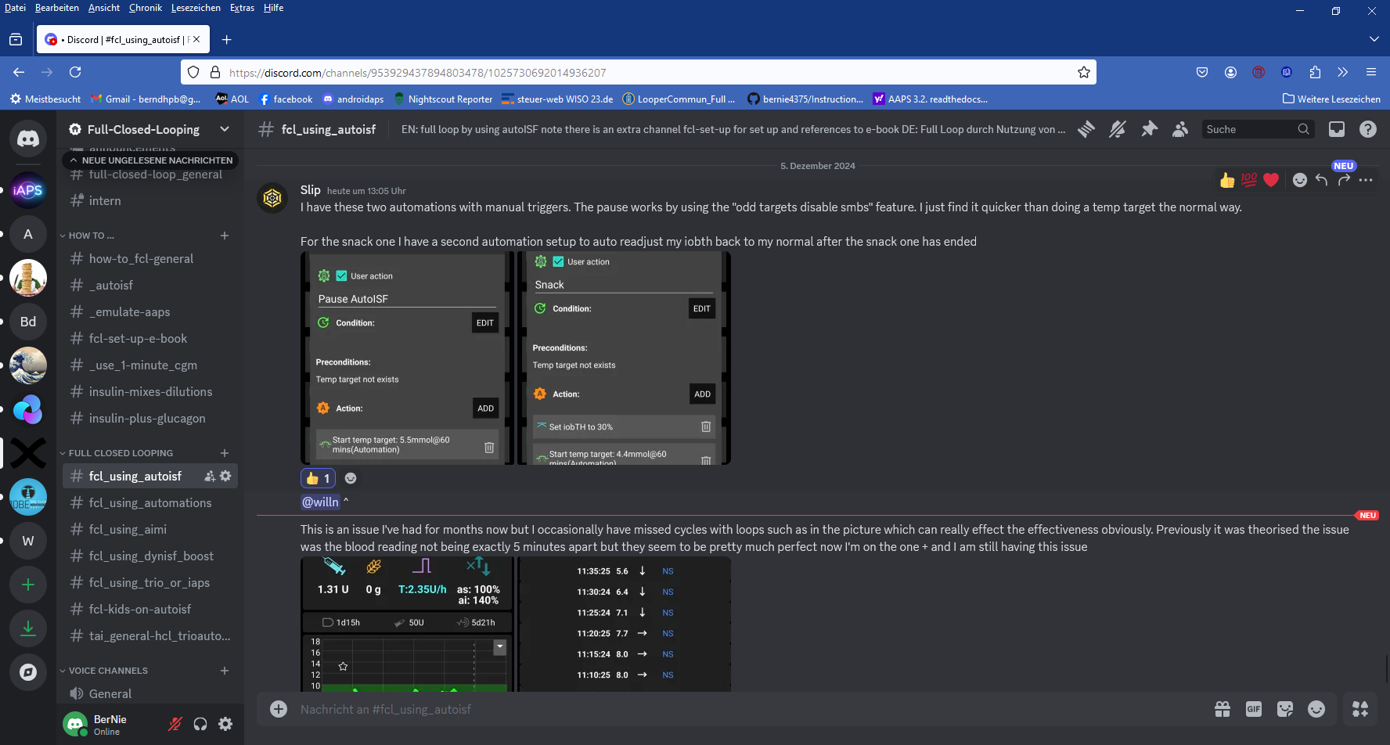
It is easy to use the top right “TT” button in the AAPS screen to switch from an even target to an odd numbered one, in order to shut off SMBs for a time you can set.

<- An even easier to operate alternative is setting up this User Action Automation called “Pause autoISF” (suggested by Slip, Discord Dec.2024).
(Actually, autoISF keeps running, but it seems paused because it can’t translate big calculated insulin requirements into SMBs)

5.2.2.2 Making temporary changes in settings made in AAPS/preferences/Open APS SMB

Caution: Trouble with some of these is, not to forget to stop and set them back, manually, too.

Going into AAPS/preferences/Open APS SMB allows to:
- set milder or stronger …_ISF_weights
- set different iob_threshold_percent (or iobMAX)
- elevate or lower the SMB_delivery_ratio
- limit or expand max. allowed SMB size
- change the the even <-> odd logic for SMB on/off
Doing temporary changes in AAPS/preferences should be the exception because
- they require multiple steps, including entering a password
- you will often forget to set everything back to original settings, a couple of hours (or already minutes) later.

5.2.2.3 Triggered Automations: Grey extra DIY cockpit buttons for pre-programmed “responses”.

In AAPS, you can build a couple of DIY cockpit features via “User Action Automations”, as described below and in case studies 5.2 and 6.2.:

Snack example.

Recognizing conditions for fully automatic handling by the loop may not be not possible, or come too late for the loop to act on. Examples would be

      - exercise: Minimum an hour before starting exercise, “the loop should know” to be able to lower iob and elevate bg by the time exercise starts. (For more, see section 6.)

      - snacks: High carb snacks, sweets, consuming ice cream or having a sweet drink comes with the problem of even steeper glucose rises, but overall a lesser insulin need, compared to major meals (for which we tuned our FCL according to section 4).

This not necessarily implies that snacks need different settings than a meal. After all, autoISF was designed to react to all available data, especially to where the developing glucose curve is headed. So, depending on your effort to set parameters for a broad variety of meals (notably: how well you avoid to invariably bounce fast against your iobTH), you might be able to accommodate low carb, snack, and major meals with one set of settings.

In FCL autoISF, this is a bit more difficult than in HCL autoISF applications, because FCL involves revving up iob supply (largely via big bgAccel_ISF-weights) sometimes too much, to be balanced by just a snack getting absorbed.

Caution: In case a snack did trigger a “full meal response”:
(1) You probably must continue snacking to prevent a hypo from your initial FCL over-reaction.
(2) For future days, analyze your data (and snacking habit) to define how to prevent this from happening . often.

For increased comfort and safety, you might have to differentiate, and make use of what follows for the sweet snack example, case study 5.2.

Note that in the iPhone versions of autoISF (Trio and iAPS) there are no Automations . Instead you need so-called Middleware, like for instance suggested for %sensitivity (profile ISF) adaptation by one user here: https://discord.com/channels/953929437894803478/1025731124615458848/1238099464531611668

Tuning aggressiveness

A sweet snack likely benefits from even more aggressive initial FCL performance than set for the meals in your normal spectrum of diets.

Therefore, you could set
- a higher temp. profile% and/or
- a temp.elevated bgAccel_ISF-weight (see screenshot of my Automation).
- a low temp. target (76 mg/dl for instance; this additionally helps maximize the first SMBs that will automatically be triggered at detection of acceleration)..

When first defining and testing this Automation, also check:
- that the safety limits as discussed in section 2 will not block the intended elevated aggressiveness
- SMBs will not get outrageously big, and iobTH sometimes exceeded by too much.
Note that “the last SMB” is allowed to overshoot the effective iobTH by up to 30%, where it will be cut.

Limiting iob

For “just a snack”, total insulin need will be lower than for a meal.
If you would just have your sweet drink, and your meal-oriented FCL would “attack”, iob likely would become too high, and a glucose rollercoaster would start, with you needing to consume more =>
If you just have a snack, or drink a small glass of juice, you can lower the iobTH_percent accordingly.
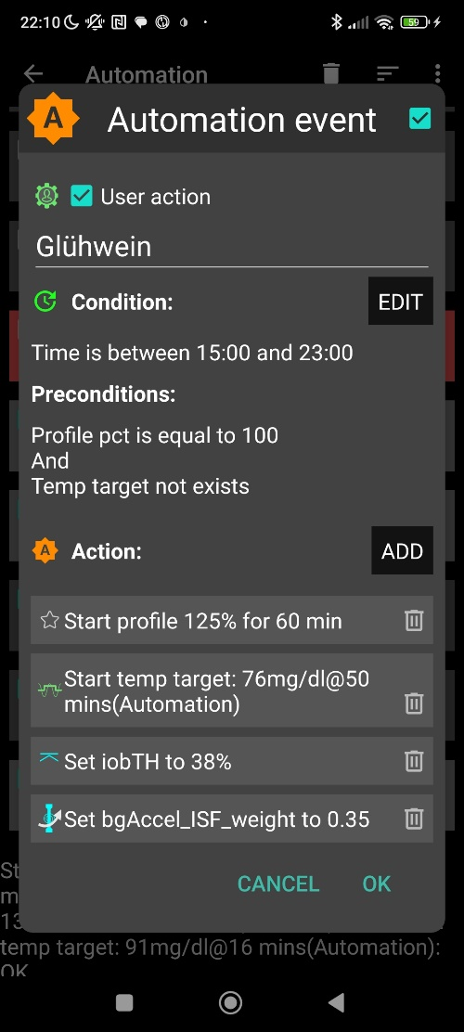
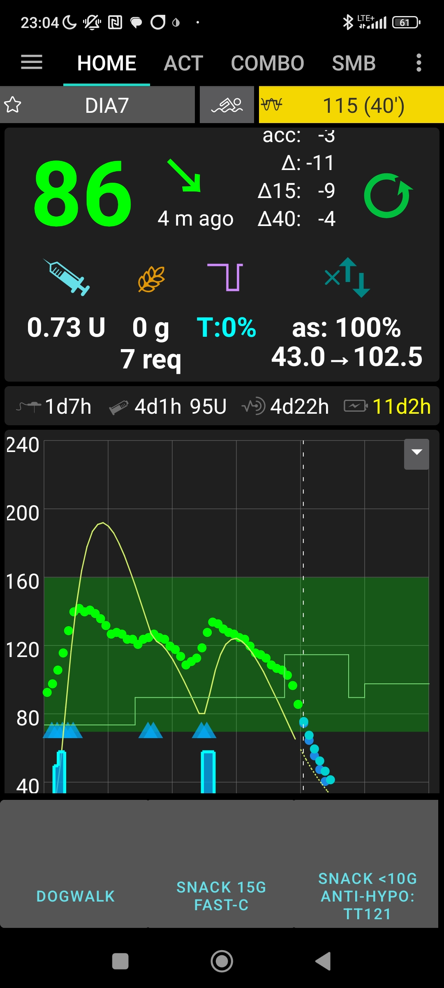
„User action“ is always ticked-on

This will, in the defined time space ..

..offer the “DIY cockpit” button..

..which I must press any time (~90…30 minutes) before my snack.

Note: Make sure that iobTH and bgAccel_ISF_weight revert to default afterwards
Snack 15g fast-C

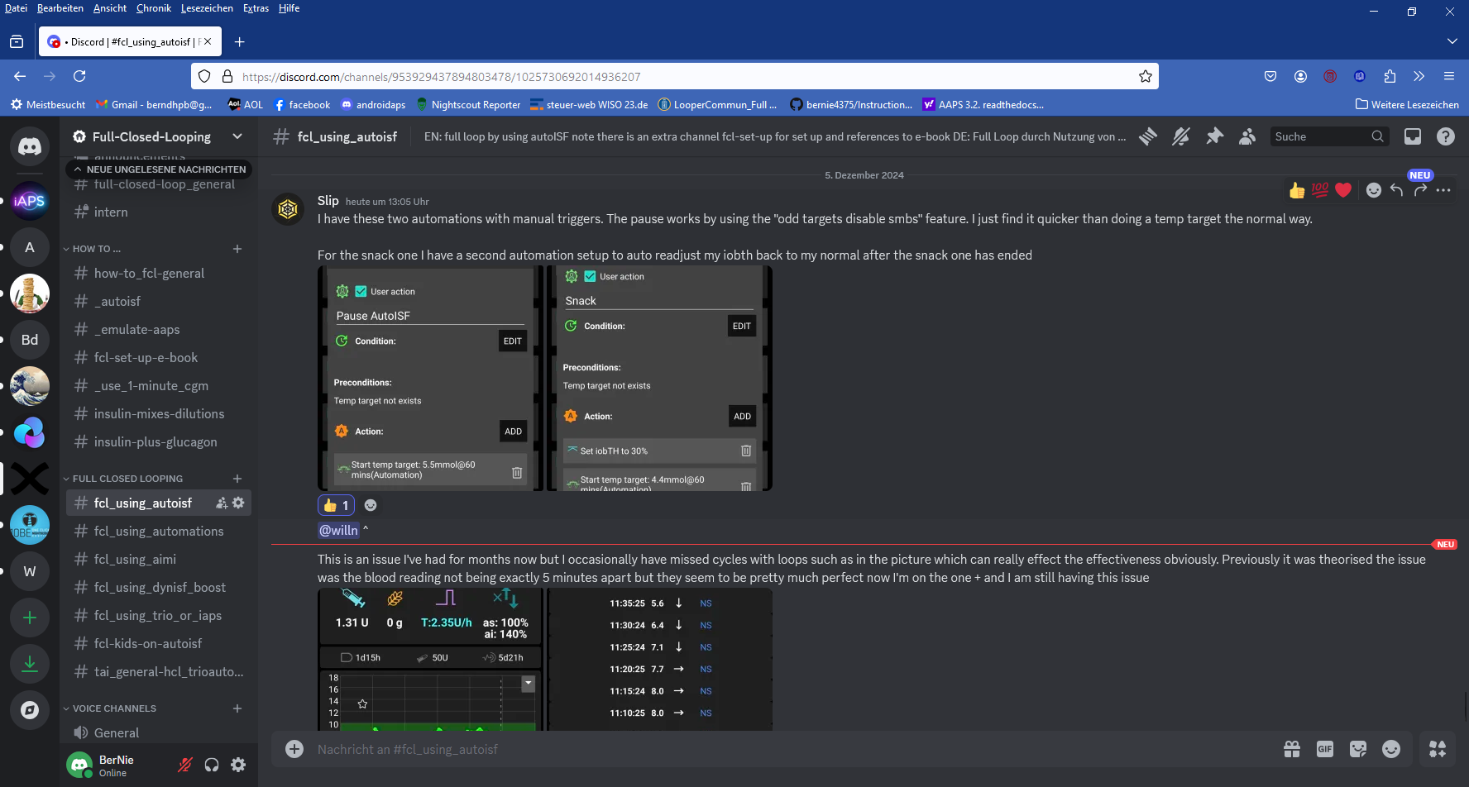
<.- A simplified way was proposed in Discord (Slip, Dec.2024 )

Again, note: Make sure that iobTH% reverts to default afterwards, ideally automatically:
- see Automation event with Action “set iobTH (to default)” (further below)

So, you as part of your setting-up project, you need to research your snack habits (if any), and over time find out which settings in the snack-related Automations work well. Then, in everyday life, you just press the related button in your cockpit (which is not time critical at all, except it should be clicked latest a couple of minutes after you took the drink or snack, when acceleration of your bg curve sets in.)

If you consume more, and also eat something with your sweet drink, this will more resemble a full meal ( … probably with unusual amounts of fast carbs => it is good to use initially the more aggressive ISF weights as in your snack Automation).

Caution: Pressing your snack button a second time would not help because the lowered iobTH does not allow iob going high enough. So you are better off just letting your normal FCL meal routine run, after your snack mode expired.

Other options (when you just can’t stop snacking) would require a manual modulation regarding %profile and/or bgAccel_ISF, but keeping the full default set iobTH_percent, or even elevating it (refer to section 5.2.3).
If that happens often, define for yourself an extra User action Automation for a bigger snack (= another grey DIY cockpit button).

Caution: Setting a different iobTH or bgAccel_ISF _weight can not be done with a duration attached.


Hence you must define a suitable additional Automation, that must be active in tandem, and restores the iobTH or bgAccel-ISF_weight in AAPS/Preferences.

Else, once your Automation set in, it will forever shift these important parameter settings!

Tandem Automation example, for restoring settings in /preferences : ----------------------------------------------

If for instance you have several Automations that, in combination with a set elevated TT also set a lower iobTH: Don’t be fooled, the duration only applies to the TT. You need an extra Automation for all of them.
In my Tandem Automation example given above, I picked out the highest of the altered iobTH values that my iobTH-reducing Automations can set (45_percent), and then I can automatically restore my default desired 60% via this one Automation (see screenshot given above )
In the related Automation, just keep the “User action” box clicked at all times, and define in the Conditions when you want to see that button available for cockpit use (see screenshot above) => you will see that button offered.

Installing your DIY cockpit buttons

Besides snacks, also any other recurring special situations can be addressed via a DIY cockpit button, and receive different aggressiveness up to a suitable iobTH level.
Over time you can have a big number of User action Automations. Best keep some “shelved” (clicked in-active, top left box) in your long list of potential Automations. Even when active, they only show in your cockpit (bottom grey field of your AAPS home screen) in the time slot you assigned as potentially relevant (and if all other conditions are met).

Summary

In case you do have a snack habit and …
- can not find settings, as in section 4. defined for your meals, that also suit your snacks
- can not pin a time slot or other Condition to it for programming an Automation response as in section 5.1.4
.. then you minimum need a “snack announcement” for which the extra button in your DIY cockpit provides a time-uncritical 1-button-push solution.

This could be a good solution for kids in kindergarten, too. Make sure caregivers understand to use it only once for a snack! Using the snack button several times in a row would limit iobTH at a too-low level! Note that continued snacking would require iob as for a meal, and that is what the FCL loop takes care of, fully automatically.

5.2.2.4 Differentiation of FCL aggressiveness using “Automation States”

This is a prototype implementation in autoISF 3.1.0 that allows further refinement of automating with autoISF parameters.
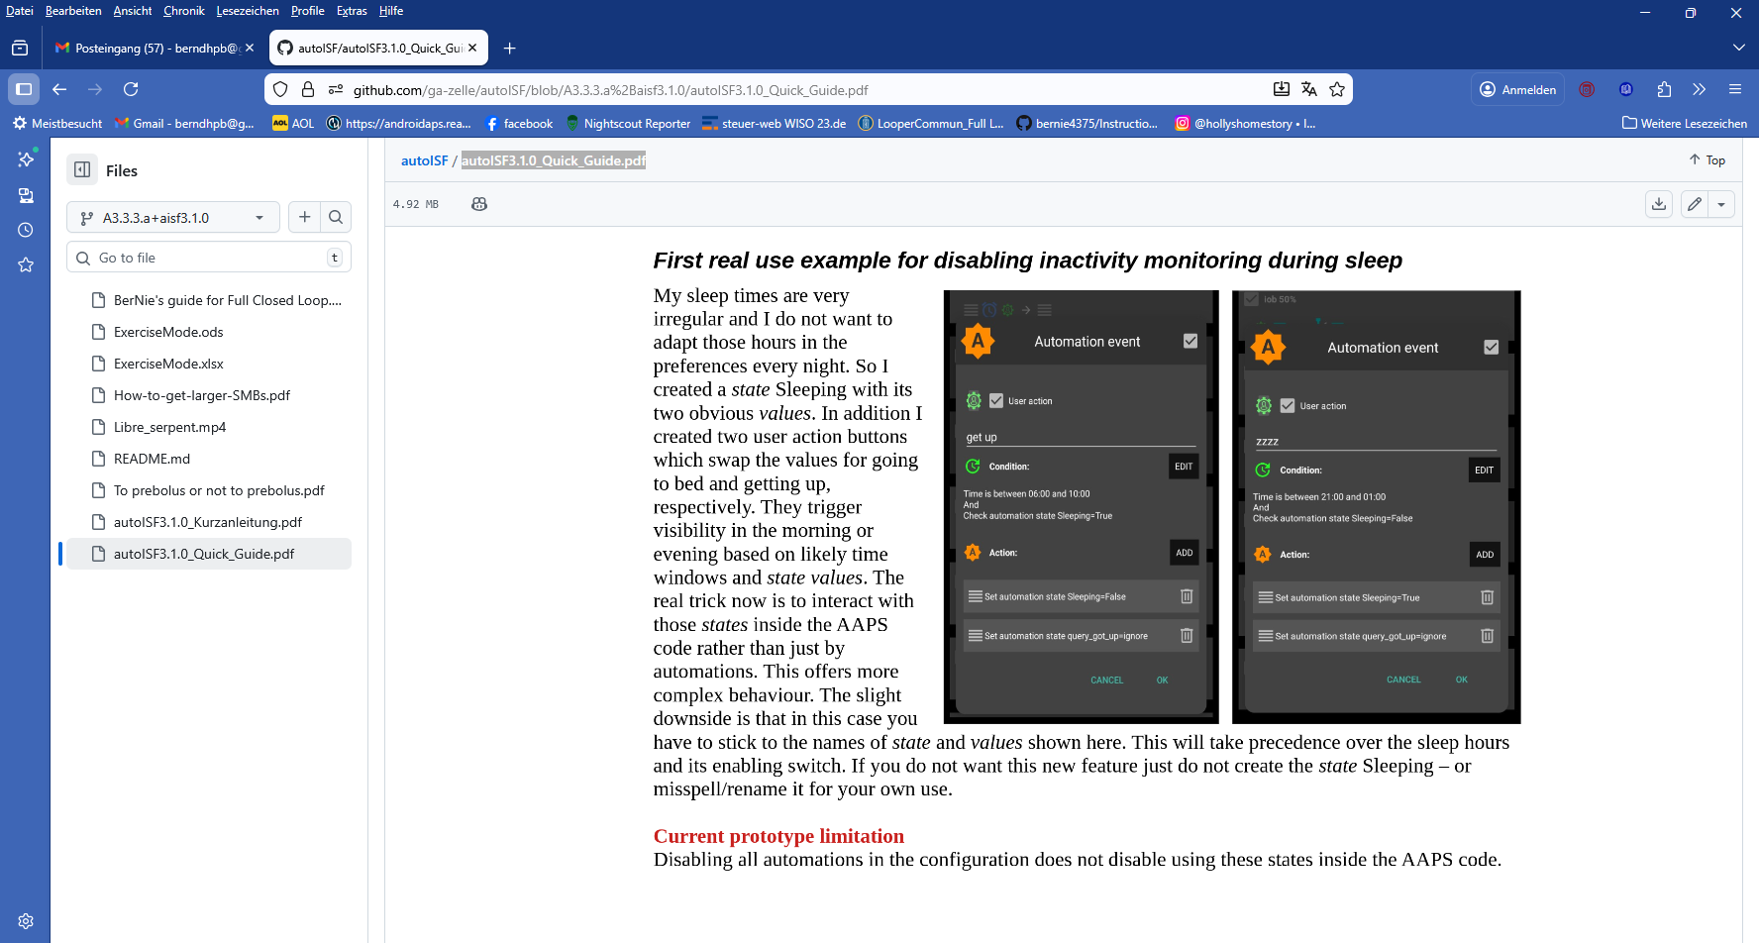
An application example is given in the developer’s autoISF 3.1.0 Quick Guide, section “The new Automation of States”:

Source: https://github.com/ga-zelle/autoISF

5.2.3 Temporarily exiting the FCL

The “last resort” alternative always is to temporarily leave the FCL mode, and handle any disturbance “the traditional way” in hybrid closed loop.

Do not forget that, before any meal starts, giving a bolus will then be necessary again.

“Enable ISF adaptation..” OFF”

This switches all automatic aggressive adaptations of ISF to the bg curve OFF that autoISF provides.

To exit the FCL mode, go to AAPS/preferences/put in your password *)/OpenAPS SMB/scrolldown to autoISF settings and switch “Enable ISF adaptation..” OFF”
(or, alternatively, set bgAccel_ISF_weight to zero).
*) please set a (very short) password, just to avoid accidential clicks when scrolling

Set bgAccel_ISF_weight temp. to zero

If in hybrid closed loop you like e.g. the dura_ISF adapation still, you alternatively could elect to just set bgAccel_ISF_weight temp. to zero.

Switching back into autoISF FCL

Caution: Unfortunately, there is no way yet for your full closed loop with ISF adaptations to come automatically back on, after a selected time for instance. So do not forget to switch your autoISF fully back on, later.

Alternative: Temp. FCL OFF via a new cockpit button

As this switching back will often be forgotten, an alternative strategy for FCL pauses would involve a custom “User action” Automation, that can give you a “Pause FCL” grey button on your AAPS Home screen (see end of section 5.2.2.1, above).

Caution though, there is very limited experience with this brand new feature. Make sure your Automation definition really applies a duration (or other condition) that will automatically terminate all settings changes it made. As we have seen e.g. in section 5.1.4, this is not always the case.

Recognizing loop state

To recognize whether autoISF currently runs with ISF adaptation or not, please consult the “ai: %” indicator below the Autosens% on the AAPS Home screen.

The 1st screen of the AUTO ISF tab is probably the best resource at your fingertips to find out in detail what is currently going on.
More see in section 5.3. that follows.

5.3 Recognizing your loop state in the AAPS home screen

5.3.1 Modulated loop aggressiveness via the 3 top buttons in the AAPS home screen

The 3 top buttons (%profile; exercise; TT) of your AAPS Home screen allow temporary modulation of aggressiveness (sensitivity), as may be needed e.g. when

- going into meals (EatingSoonTT => providing lower bg “starting point” and more pos. iob),
- or doing exercise (Exercise mode, limiting basal, iob etc for hypo prevention).

All buttons grey (GGG) indicates: The loop is running using un-modulated profile parameters

Note that autoISF builds on profile (or on a temp. modulated profile) for further “5-minute“ modifications (See calculation cascade for used sensitivity (sens) in the AUTO ISF tab. Example see below in section 5.3.6 ).
Any yellow (y or Y) button indicates you are running with a modified (elevated, or lowered) profile sensitivity.
Actually, the middle button could be yellow without being active, see table below

 | Less aggressive loop = more sensitive user needs temp. less insulin | Standard loop using the set profile | More aggressive loop = less sensitive user needs temp. more insulin
% profile | under 100 % (y) | = 100% (G) | above 100% (Y)
Exercise button | ON (y)  Note that it will only work in combination with elevated TT | OFF (G) | OFF (G)
 |  | If ON (y), it is not active but ready to automatically become active whenever any TT above target is set (e.g. by any Automation)
TT | above profile target (y) | = profile bg target (G) | below profile target (Y)
Example | Exercise mode with weakened %profile, yyy |  | EatingSoonTT, GGY
..used e.g. in : | Case study 6.2 (yyy) |  | Case study 6.2 (G_Y via Automation)  Case study 5.2 (YGY)
Case study 6.2 uses extremes from both ends of this sensitivity modulation spectrum:
- yyy for reducing basal and iob, and getting weaker ISF, during exercise
- GGY for temporary “EatingSoonTT” boost when, in FCL, a high carb meal had
- The even stronger YGY case is contained in Case study 5.2, where for a high carb snack an extra boost, using >100% profile sensitivity, is temp. added

5.3.2 Color scheme of top cockpit buttons tells kind of closed loop that is running
This section is fairly complicated, not fully checked with Devs, and not crucial to understand: Skip and continue at 5.3.3

3 Buttons (%profile; exercise; TT), each in 2 states, yellow (for modified), else: grey (G)
Note that yellow could be less (y) or more (Y) aggressive than standard profile
Any yellow setting modulates sensitivity or attempts to modulate, whenever another required condition may become true (e.g. also via an Automation
Note, though, there are EXCEPTIONS (see below, under GGG, and under Gyy) where sensitivity is auto-adjusted without the user, or an Automation, making a different setting on any of the 3 top buttons. Autosens, or the Activity Monitor, can adjust the %profile sens without the top left button turning yellow or showing that %value. (See sens field in AAPS main screen, or AUTO ISF tab!)

- GGG is the loop running with set profile.
EXCEPTION: If the Activity Monitor or Autosens are running, profile sensitivity could be adjusted to (in)activity despite the %profile button remaining grey (see top of AUTO ISF tab text from AAPS main screen). Liikewise, Autosens can temp. tweek the set profile, with the button still remaining grey,
Overall, 2 exp 3 = eight principal FCL modes are possible. They need to be differentiated further, based on whether the modulation…:
- …goes into the more aggressive (Y, higher % and/or lower TT), or…
- …the less aggressive (y, lower % and/or higher TT and evtl exercise) direction.
- Note the Exercise button works only one way, to make the loop less aggressive (“y”). However, whether the dynamic Exercise Mode (which strongly can adjust sensitivity, see section 6.1.3.1) is at work, cannot be recognized by the color of the Exercise button:
Dynamic Exercise Mode (dyn.EM) ? | bg target as in profile: grey | TT > profile target set (Yellow)
Exercise : grey | dyn.EM off | dyn.EM off
Exercise: yellow | dyn.EM off (!) but “on in waiting” = after an Automation sets a TT>profile target | dyn.EM on

DEV idea: Should we make the Y to violet or orange (more aggressive) and keep the y yellow (less aggressive than profile)? Then beginners would easier recognize whether they go more or less aggressive …
Color combinations | Lower aggressiveness | …….. | Higher aggressiveness
GGG |  | profile
Gyy …. GyY | dynamic exercise mode (if TT > profile target) |  | EatingSoonTT (as TT < profile target: middle y inactive, GyY = GGY 2 )
 | EXCEPTION: Profile sensitivity is auto-adjusted in dynamic exercise mode, but this leaves the 1st button grey (G)
yGy-yGY- YGy-YGY | „traditional“ exercise mode  (if <100% sens AND TT > profile target) | mixed cases 1) | boosted EatingSoonTT (if >100% sens AND TT < profile target)
GyG |  | GyG = GGG 2)
yGG …. YGG | Loop adjusted for period of lower insulin need (e.g. 80% for night after exercise) |  | Loop adjusted for period of increased insulin need (e.g. 120% during sickness)
 | The set %profile might be further adjusted by Activity Monitor or by Autosens
GGy ….. GGY | Loop running with temp elevated target e.g. for enhanced safety against going low (HypoTT) |  | EatingSoonTT (if TT < profile target)
yyG …… YyG | same as yGG | y inactive 2) | same as YGG
yyy - Yyy- yyY- YyY | dynamic exercise mode further modulated by <100% profile | mixed cases 3)  yyY = yGY, 2) | Boosted EatingSoonTT (if >100% sens AND TT < profile target)( YyY = YGY, 2)

- yGY would be the combination of setting a milder % profile, yet orienting the loop to a lower target. Usually we do not use this combination, but it would be OK for an instance where we want to start the next meal at a low target, but we want our loop to be careful and not rush getting there.
YGy would be the combination of setting a more aggressive % profile, yet orienting the loop to a higher target. Usually we do not use this combination, but it would be OK if we believe we are in a state of enhanced insulin need, and want to get to a set elevated TT (which could be what we want to go max down to to have room for exercise, or just to be sure not to go into a hypoglycemia if we misjudged the symptoms about enhanced insulin need.
- GyG is the same as GGG, differing only if (e.g. an Automation) sets a TT>profile target. The GyG setting only then provides softer loop response, due to the exercise mode kicking in.
Generally, a yellow middle button y works really only in the combination ..yy. Any combination ending yG or yY will work the same as if it were ending GG or GY. Although the yellow middle button does not make a difference in these cases, it might be “justified” by the loop showing its readiness to employ the exercise mode, whenever a TT > profile target comes around, e.g. via an Automation.

- yyY would essentially working like yGY (discussed under 1), because the middle button, whether y or G, makes no difference with an elevated TT.
Again, this the combination of setting a milder % profile, yet orienting the loop to a lower target. Usually we do not use this combination, but it would be OK for an instance where we want to start the next meal at a low target, but we want our loop to be careful and not rush getting there.
Yyy would be the combination of setting a more aggressive % profile, yet orienting the loop to a higher target. As opposed to the YGy case (discussed under 1), in Yyy the Exercise mode is active and strongly reduces aggressiveness. It is hard to imagine, why this combination this combination of settings could make sense; maybe if a “long waved” state of reduced insulin sensitivity meets a case where normally Gyy would be sought (see there).

5.3.3 Active Automations (or middleware in Trio, iAPS)

Active Automations can temporarily set different aggressiveness and, in AAPS, will automatically adjust to the color scheme discussed in the previous chapter.

It is important to be aware, which of your Automations (see listed in your AUTO tab, or via the top left burger menue, in AAPS) is active to eventually “kick in”.
The ones where you clicked “User Action” should also show as an extra grey button on the bottom of your AAPS screen (only in the suitable time-of-day bracket, if you assigned one).

Note that an Automation might not be permitted to change settings if still another Automation is running.
Always consider that. Try to use short durations in all your Automations! Note that usually you do not lose anything by that, because, if your trigger-Condition remained, the same Automation will repeatedly trigger.

For instance, you cannot switch from 130% profile to 110%. Either the 130% times out, or you need an extra “in-between” Automation that terminates the 130% under described conditions (example see in Case study 6.2).
This “design” is for a good reason: The assumption here is, that your 1st Automation (the 130% in the example) is designed well and runs for a reason. It should either “get finished” when the job might be done (and kick in again, if not), or, in exceptional cases, it should be consciously terminated by another well thought through 2nd Automation (describing the conditions in which you would find that another Automation now is more important than “finishing up” the one that was already running). That “in-between” Automation makes the loop return to base profile, which is a signal to all Automations, to now check whether any conditions exist, to activate a 3rd Automation. (An example is given in Case study 6.2).

Advice: 1) Do some “house cleaning”: Occasionally check which of your Automations might work with shorter durations assigned. Reduce your long list of Automations, or at least de-activate those that will not be needed.
In case you have many Automations and a very varied life-style, you could make it an evening routine to have only those Automations activated that you might need next day.
2) Try to stay away from Automations that also aim at temp. modifying aggressiveness (especially if triggered by bg level). Often, they will not kick in anyways. And generally, it is not a good idea, to “double up” sub-algorithms for tweaking loop behaviors (“loop inside a loop”).(see also at end of section 5.1.4)

5.3.4 FCL related indicator fields in the AAPS home screen

In extra data fields of the AAPS main screen you can always see (not change) the key „aggressiveness“ parameters your loop currently operates operates with (see also home screen example below):
- To recognize whether autoISF currently runs with ISF adaptation or not, please consult the “ai: %” indicator below the Autosens% on the AAPS home screen.
- Details for every loop decision see result/debug section of the AUTO ISF tab.
5.3.5 Overall home screen: )
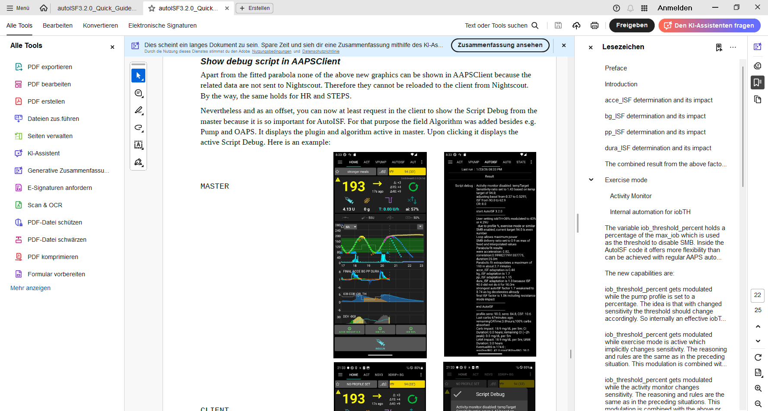
better: see section 5.3.6
5.3.6 Client screen
Apart from the fitted parabola (pink line, around 20:30 in the graph), none of the above new graphics can be shown in AAPSClient (because the related data are not sent to Nightscout. Therefore they cannot be reloaded to the client from Nightscout. By the way, the same holds for HR and STEPS.)
Nevertheless and as an offset, you can now at least request in the client to show the Script Debug from the master because it is so important for AutoISF. For that purpose the field “Algorithm AUTO_ISF” was added besides e.g. Pump and OAPS. It displays the plugin and algorithm active in master. Upon clicking it displays the active Script Debug. Here is an example:

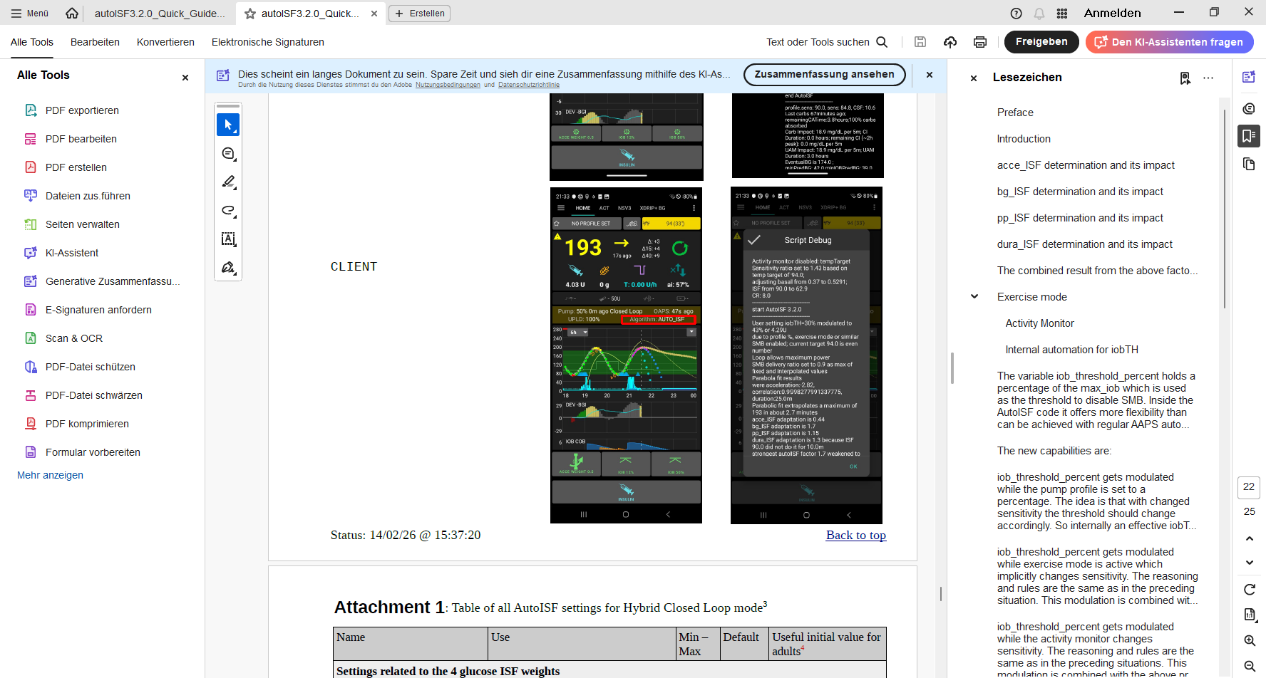

5.3.7 autoISF related infos on the main screen
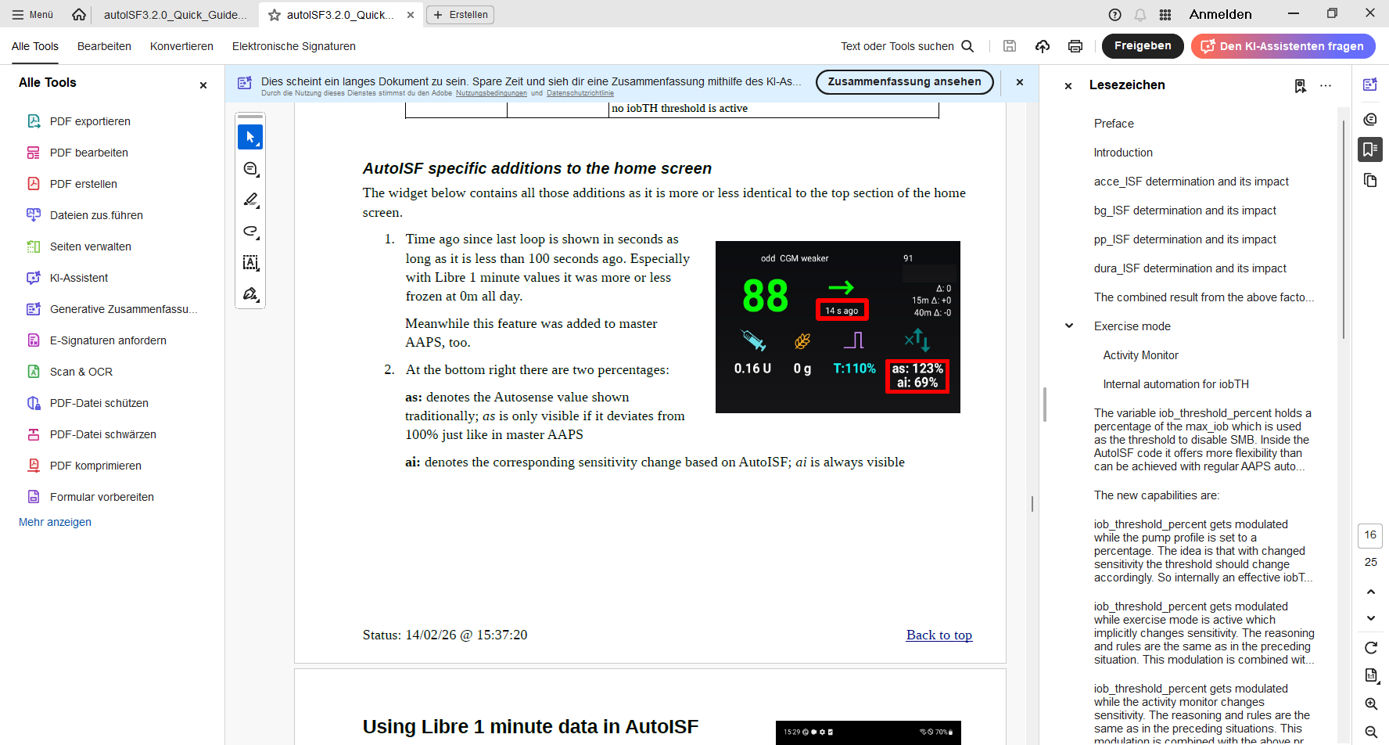
Note: From autoISF 3.2 onwards, displaying the acc value (top right, underneath the TT field) was discontinued, now that the parabola is shown

The extra graphs available in AAPS below the main glucose chart, recently received an upgrade to include autoISF info:
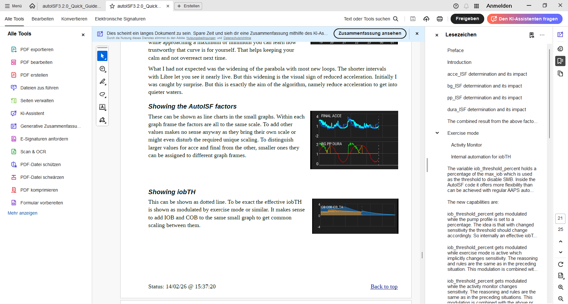
Note: FCL users would have COB=0, i.e. not see an orange field (except as “carb deviation” in an extra graph “DEV”)

No more buttons „Insulin“, „Calculator“ etc at bottom of AAPS home screen
These buttons are not useful any longer in FCL, and should normally be removed (by going into /preferences/overview/buttons and forcing them OFF).
The reason why we do this: It really is important to let the loop loop, and not interfere more than absolutely needed. Any bolus the user gives will sure distort the bg curve, on which autoISF, especially when aggressively tuned for FCL, builds a lot of its decisions!
Note: Eventual attractiveness of doing occasional pre-boli will be discussed in section 7

5.3.8 Info given every 5 minutes in the AUTO ISF tab *) (If tab not shown -> Config.builder/APS: tick box on the right)
*) in older autoISF versions: “SMB tab”
When clicking on the AUTO ISF tab, you see how your standard and temporary settings, as well as the latest bg and iob status, influenced the last decision of your FCL.

Example 1: A 80% temp. profile modulates 60% iobTH to 80% of 60% = 48%:
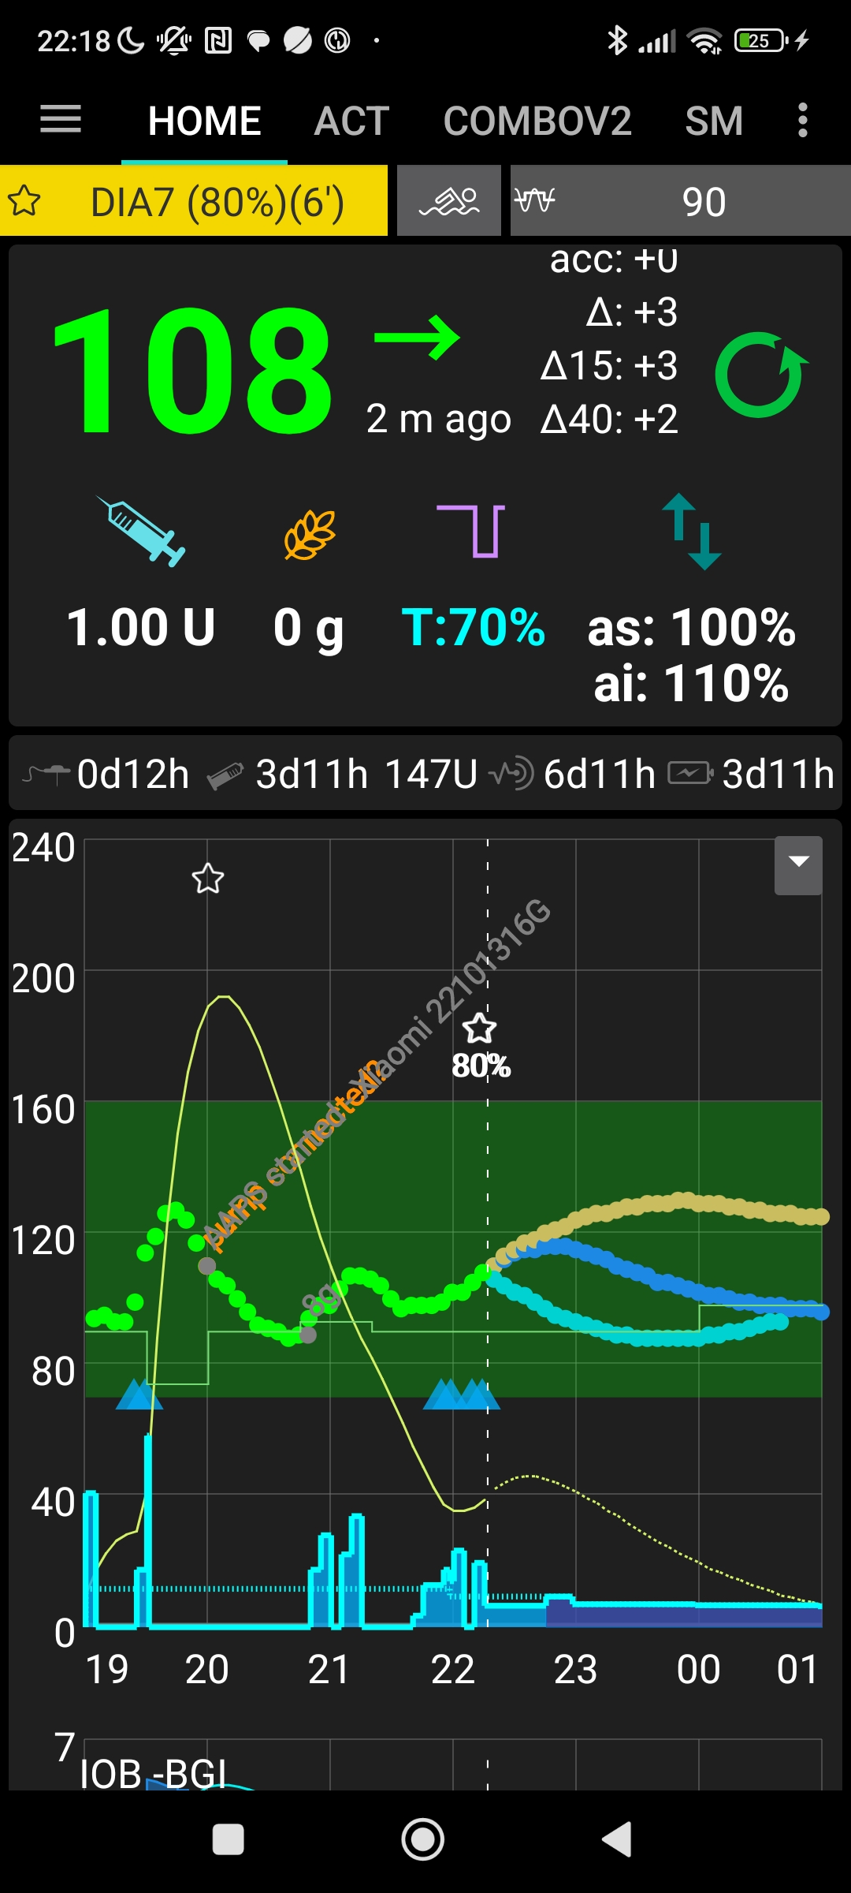

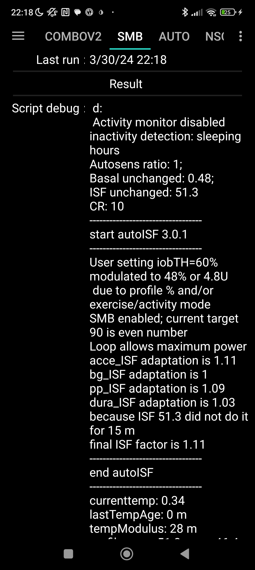

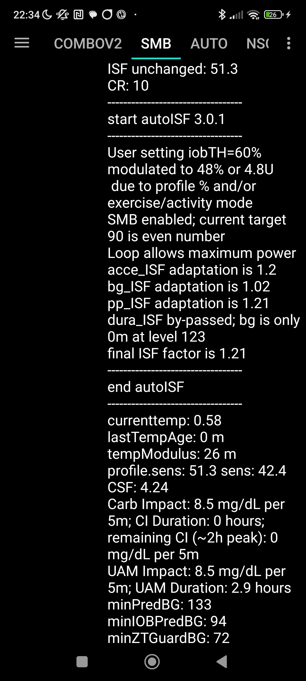

Summary

The profile ISF of 41 mg/dl/U got modified by the set 80% temp. profile to 41/0.8 = 51.3 mg/dl/U, called “ISF unchanged” (before “start autoISF”).

autoISF applies the 4 sub-categories (acce, bg, pp and dura_ISF), and depending on the bg curve form suggests various ISF changes.

The final resulting factor “sens” (see flowcharts in section 3) is 1.11 (in our case, driven by bgAccel_ISF). This changes the 51.3 “unchanged” ISF to 51.3/1.11 = 42.4 mg/dl/U

Further down in the AUTO ISF tab, you can see how this ISF is applied to define the SMB size to be given, and whether any limitations – notably by autoISFmax, max possible SMB size, or maxIOB – cut the amount.

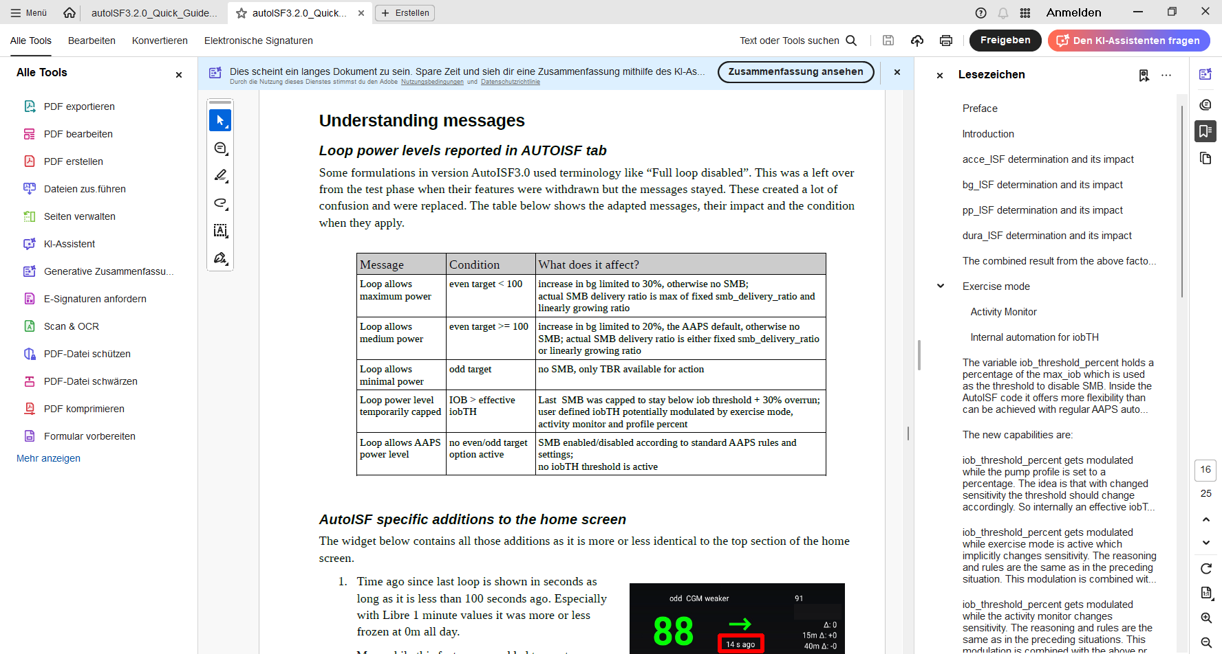
Note that in the AUTO ISF tab you can only capture and analyze 1 loop decision.
(Occasionally make screenshots ~ every 5 minutes in the critical stages, for analysis of a meal)

Note that in the AUTO ISF tab you can– in “real time” - capture and analyze only one decision.

5.3.9 Info about last 15 autoISF decisions

Refer to section 11.2.2 for an option that enables extended analysis of the on-going ISF modul-ations from autoISF. (To do this on your Android loop phone requires QPython and a logfile emulator).

You get tables like this …
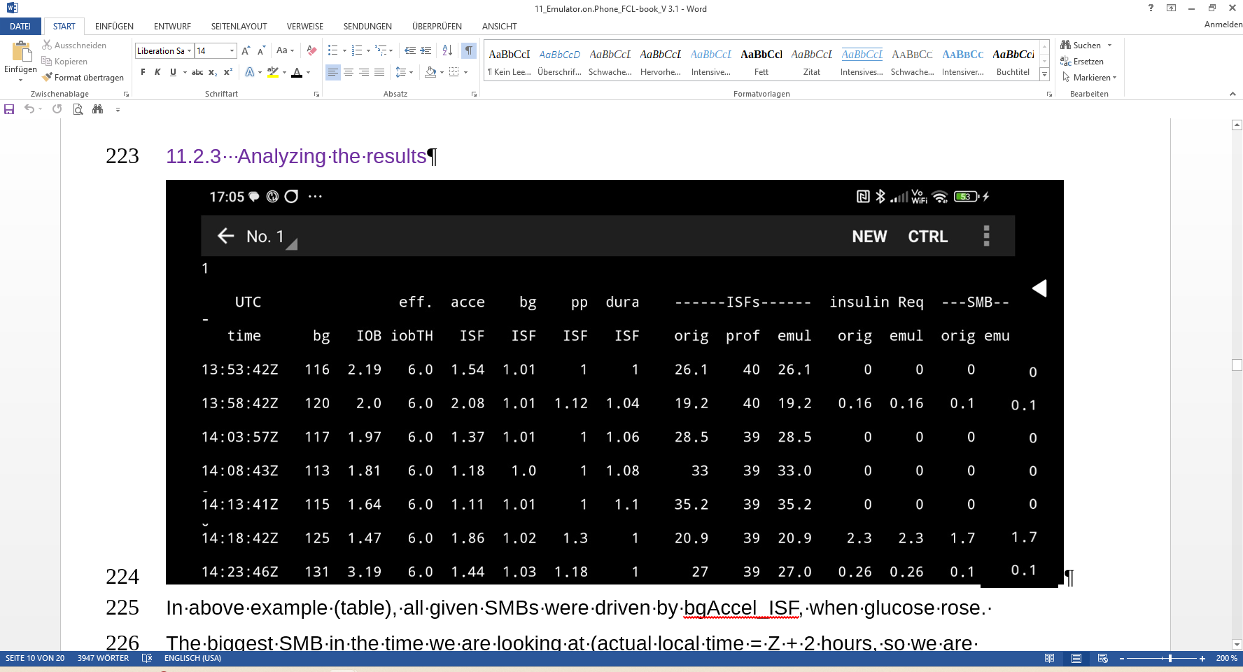
… which gives you a quick orientation about recent loop decisions, and relative contributions of the various autoISF contributors (ace, pp, bg, dura).

A similar table is available also on the iPhone for Trio and iAPS users of their autoISF variants.

5.3.10 AUTO ISF tab info when operating in 1-minute mode with Libre3

Users: Please supply text and screenshot

Summary: Your personal FCL cockpit for maneuvering through disturbances

A lot of avenues were shown that could help you or your loop maneuver through a variety of “disturbances”. You should not have to try out many of them. Find a way to narrow it down to what really helps in your everyday T1D management.

Try to keep things as simple and clear as possible.

Especially, do not pre-maturely rush into setting up Automations as quick over-patches for what you may not like to see. Limit the number of Automations, and further limit which ones from your list are every-day active (vs. switched off, and only ticked active for special days). See also at end of section 5.1.4

